Research outline
Data set:
- Cleveland dataset
  - 297 samples used with all 13 features
  - 6 samples removed because of missing values
Feature selection:
- Relief
- Minimal-Redundancy-Maximal-Relevance
- Least-Absolute-Shrinkage-Selection-Operator
- Local learning-based feature selection
- Proposed: Fast Conditional Mutual Information (FCMIM)
Classifiers:
- Logistic Regression
- Support Vector Machine
- Naïve Bays
- Artificial Neural Network
- Decision Tree
- K-Nearest Neighbor
Performance Evaluation:
- Accuracy
- Sensitivity
- Specificity
- Precision
- MCC

Obtained Results
Performance of classifiers on full features set
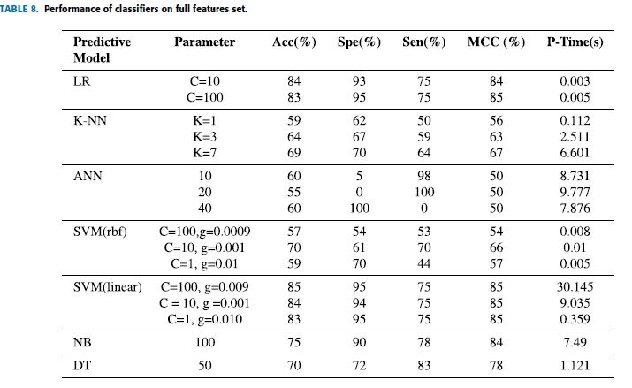

Performance of classifiers on features selected by Relief
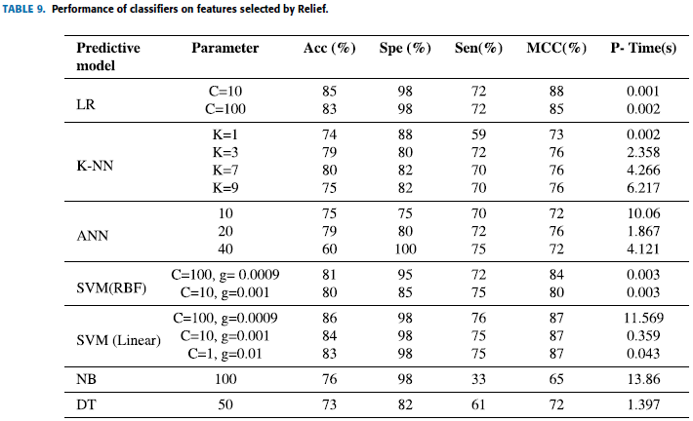

Results of classifiers on features selected by MRMR.
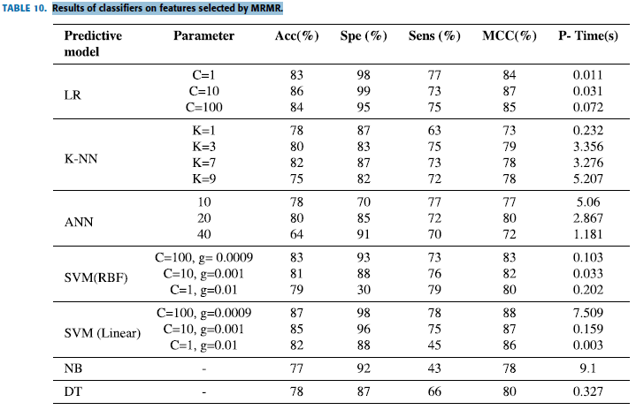

Results of classifiers on s features selected by LASSO.
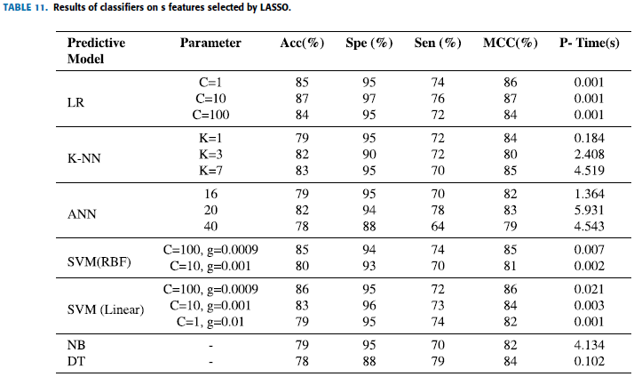

Results of classifiers on features selected by LLBFS.
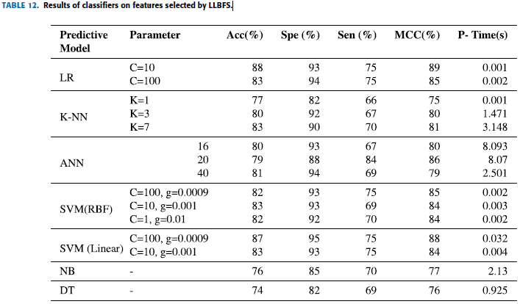

Classifiers results on features selected by FCMIM.

